**Lab Report-01**

|  |  |
| --- | --- |
| **Course Code:** | **Course Title:** |
| CSE 416 | Web Engineering Lab |

|  |  |
| --- | --- |
| **Lab Report Details** | |
| Lab Perform Date | : 19/05/2025 |
| Report Submission Date | : 26/05/2025 |

|  |  |  |
| --- | --- | --- |
| **Submitted To** | **Submitted By** | |
| **Ms. Nishat Sadaf Lira**  Lecturer  Department of CSE  Daffodil International University. | Name  SID  Section  Daffodil | : Munna Biswas  : 221-15-5261  : 61-J2  International University |
|  | |

**Experiment No: 01**

**Experiment Name:** HTML Tags.

**Objective:**

The objective of this lab is to explore and understand the structure and functionality of 30 commonly used HTML tags. This includes studying their syntax, attributes, and real-world usage through code snippets. By implementing these tags in a sample webpage, students will learn how each tag contributes to the layout, content organization, and user interaction on websites, forming the foundation for effective web development.

**HTML Tags Overview:**

|  |  |  |  |
| --- | --- | --- | --- |
| **No.** | **Tag** | **Description** | **Common Attributes** |
| 1 | <html> | Root of the HTML document. | – |
| 2 | <head> | Container for metadata and links to resources. | – |
| 3 | <title> | Sets the title of the document (browser tab). | – |
| 4 | <meta> | Defines metadata (character set, page description). | charset, name, content |
| 5 | <link> | Links to external resources (e.g., CSS files). | rel, href, type |
| 6 | <style> | Embeds internal CSS styles. | type, media |
| 7 | <body> | Main content of the HTML document. | bgcolor, text (deprecated) |
| 8 | <h1>–<h6> | Header tags, <h1> is most important. | align (deprecated) |
| 9 | <p> | Defines a paragraph. | align |
| 10 | <br> | Inserts a line break. | – |
| 11 | <hr> | Horizontal line. | size, width, color (deprecated) |
| 12 | <a> | Creates a hyperlink. | href, target, title |
| 13 | <img> | Displays an image. | src, alt, width, height |
| 14 | <div> | Block-level content section. | id, class, style |
| 15 | <span> | Inline content wrapper. | id, class, style |
| 16 | <ul> | Unordered (bulleted) list. | type (deprecated) |
| 17 | <ol> | Ordered (numbered) list. | type, start, reversed |
| 18 | <li> | List item. | value (for <ol>) |
| 19 | <table> | Creates a table. | border, cellpadding, cellspacing |
| 20 | <tr> | Table row. | – |
| 21 | <td> | Table data cell. | colspan, rowspan, align |
| 22 | <th> | Table header cell. | colspan, rowspan, scope |
| 23 | <form> | Input collection container. | action, method, name |
| 24 | <input> | Single-line input. | type, name, value, placeholder |
| 25 | <textarea> | Multi-line input field. | rows, cols, placeholder |
| 26 | <button> | Clickable button. | type, onclick, name |
| 27 | <label> | Label for a form field. | for |
| 28 | <select> | Drop-down selector. | name, multiple, required |
| 29 | <option> | Option in a drop-down list. | value, selected, disabled |
| 30 | <iframe> | Embeds another HTML page inside the current page. | src, width, height, title |

**Code Snippets and Outcomes:**

1. **<title> </title>**

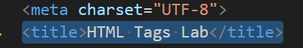

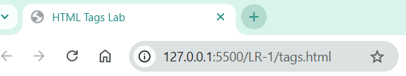

1. **<h1> </h1>**



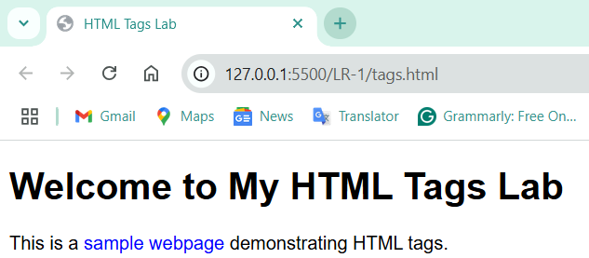

1. **<p></p>**



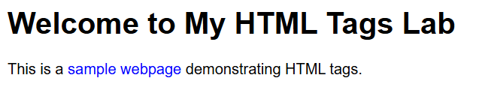

1. **<Img>**



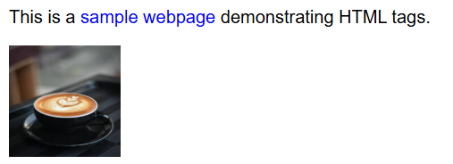

1. **<hr>**



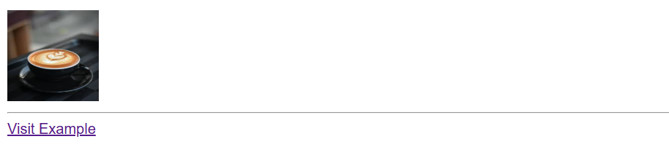

1. **<a></a>**



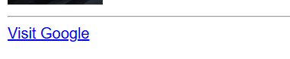

1. **<ul></ul>, <ol></ol>**

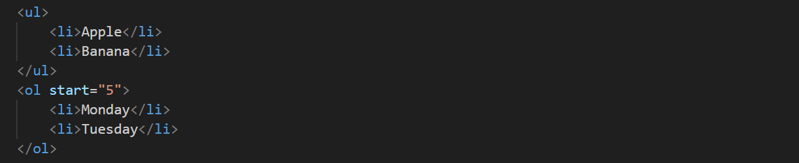

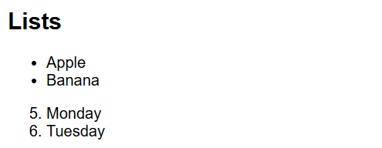

1. **<table></table>, <tr></tr>, <td></td>**

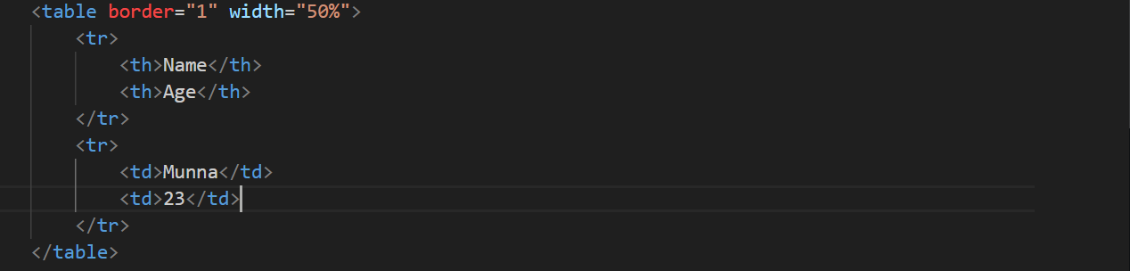

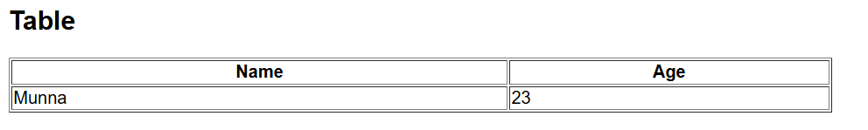

1. **<label></label>, <input></input>**





1. **<form></form>**

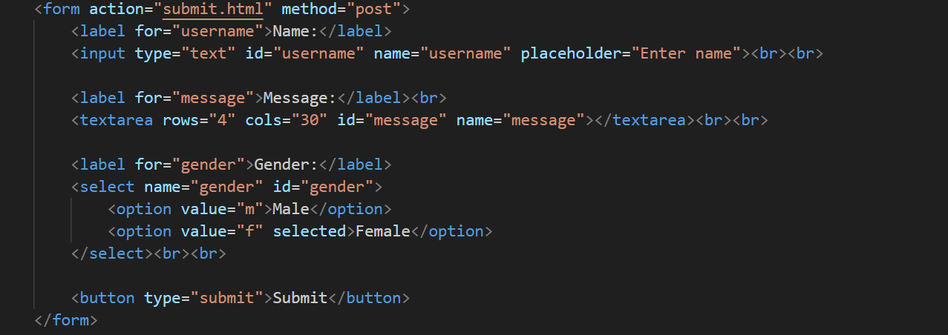

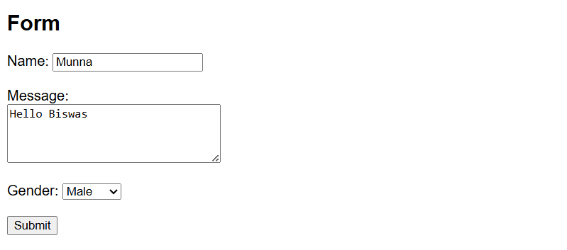

1. **<button></button>**

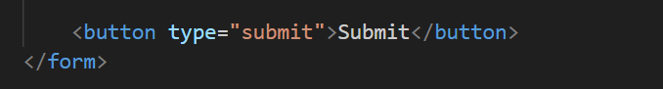

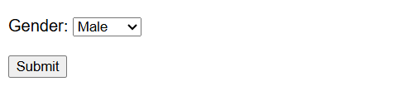

**Conclusion:**

Each tag plays a critical role in web development:

* **Structural Tags** (<html>, <head>, <body>, <div>) create the skeleton.
* **Text & Media Tags** (<h1>, <p>, <img>) help present information clearly.
* **List & Table Tags** allow for organized data representation.
* **Form Tags** collect user input effectively.
* **Styling Tags** like <style>, classes, and <span> allow visual customization.
* **Interactive Tags** (<a>, <iframe>, <button>) enhance functionality.

Combining these elements provided a rich, interactive, and well-structured website, showcasing the foundation of modern web development.

References:

<https://www.w3schools.com/TAGS/default.asp>

<https://www.geeksforgeeks.org/html-tags-a-to-z-list/>

<https://developer.mozilla.org/en-US/docs/Web/HTML/Reference/Elements>